

Multi store view pricing – Magento 2

USER MANUAL

Supported Version: 2.0, 2.1, 2.2, 2.3

Table Of Contents

Preface ......................................……………………………………......3

Installation...................................………………………………………..4

Option 1: Magento 2 install extension using COMMAND LINE .........…………..…..4
Option 2: Magento 2 install extension manually ………………………………….......5

Backend Example ………………………………………………………...……...6

Extension Configuration………………………………………………………...6

Frontend Example………………………………………………………………….9

Csv Description………………………………………………………………………13

Preface:

- Almost websites contains different multi store view which associated with
different regions and zones.

- In these cases, store owner needed to setup currency of particular area, region
or zone.

- Mageants has developed best solution.

- According to Now his/her store store owner view can set currency zone by
installing.

- Mageants Multi Store View Pricing extension. Store owner can set price of
product and set currency for particular store view.

Installation:

There are two ways of installing extension in magento2.

1) Using COMMAND LINE.
2) Manually install extension.

Option 1: Magento 2 install extension using COMMAND LINE (Recommended).

Follow below steps to install extension from the command line.

Step 1: Download the extension and unzip it.

Step 2: Upload it to code directory in your magento installation’s app directory.
If code directory does not exists then create.

Step 3: Disable the cache under System → Cache Management.

Step 4: Enter the following at the command line:
php bin/magento setup:upgrade
php bin/magento setup:static-content:deploy

Step 5: Once you complete above steps log out and log in back to the admin
panel and switch to Stores → Configuration → Catelog → Price → Scope →
Store view. The module will be displayed in the admin panel.

Option 2: Magento 2 install extension manually.

Step 1: Download the extension and unzip it.

Step 2: Upload it to code directory in your magento installation’s app directory.
If code directory does not exists then create.

Step 3: Disable the cache under System → Cache Management Edit
app/etc/config.php file and add one line code:
‘Mageants_Multistoreviewpricing’ → 1

Step 4: Disable the cache under System → Cache Management

Step 5: Once you complete above steps log out and log in back to the
admin panel and switch to Stores → Configuration → Catelog → Price → Scope → Store view, the module will be displayed in the admin panel.

Backend example

After Installation of Extension login to magento admin panel to set configuration of the extension.

Extension configuration

As per below screen shot you can set all the settings here. Set Price Scope:
Stores -> Configuration -> Catalog -> Catalog > Price – Select
Storeview dropdown.

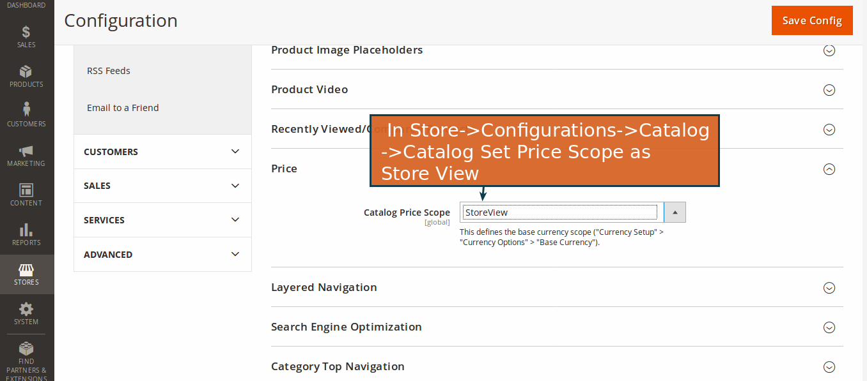

Import Multi Store View Pricing using csv file here.

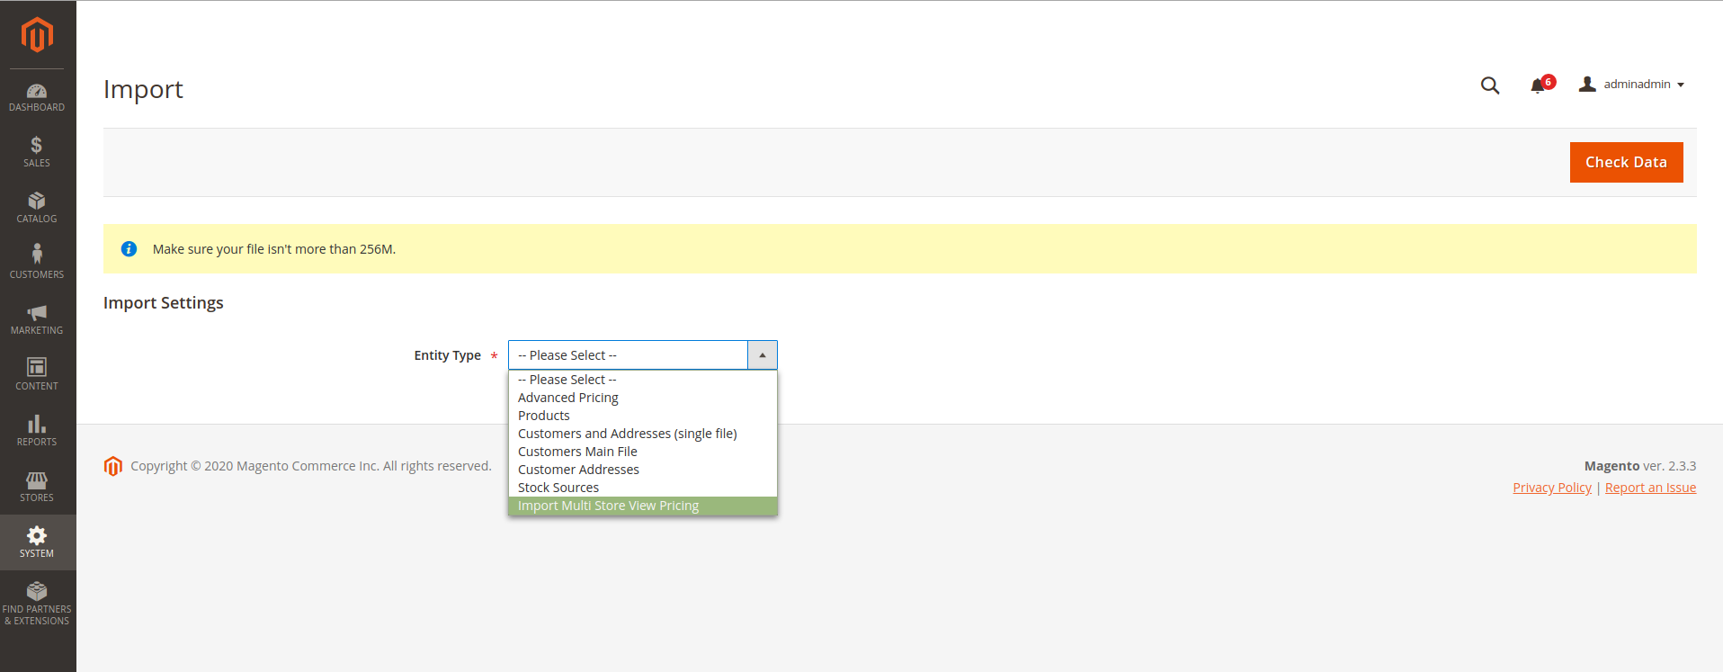

If you wan’t to download uploaded csv then click on link.
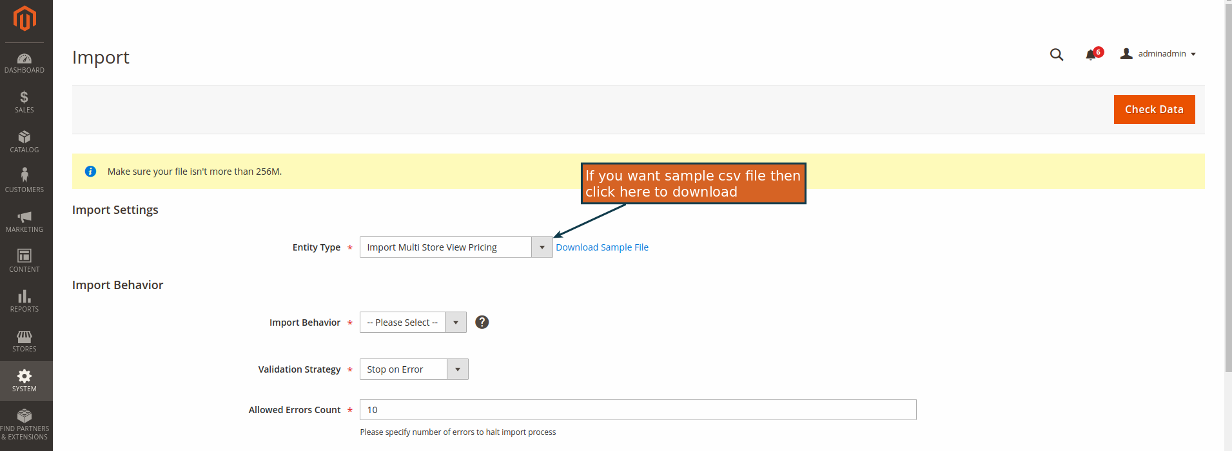

After Checkdata,if error occure then show otherwise import file here.

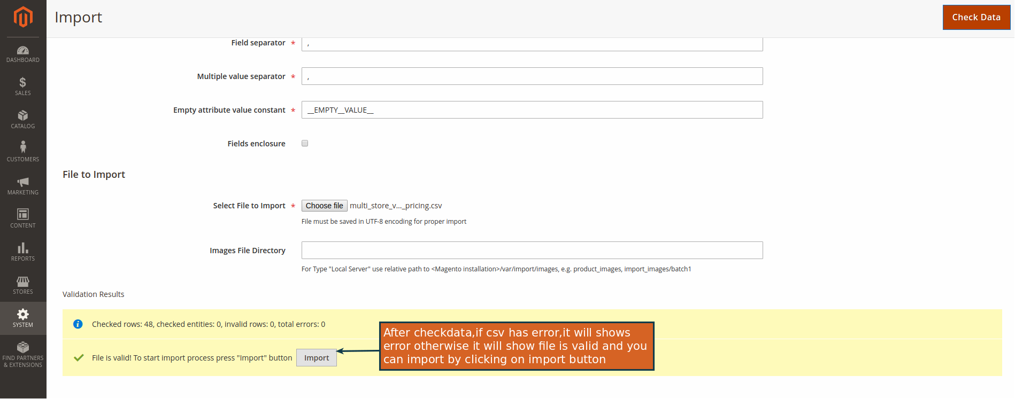

Edit Price & Advance price for products
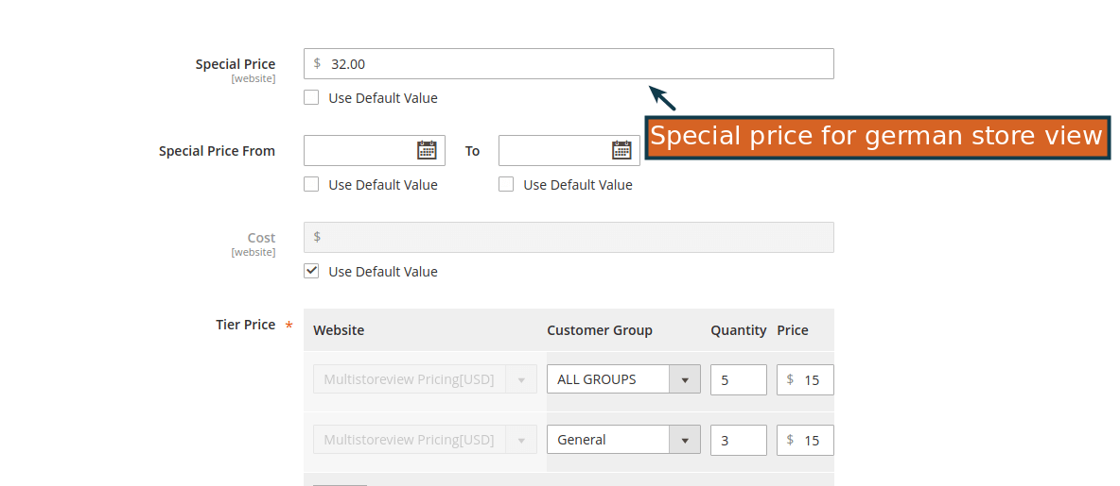

Set Price for different Store view wise here
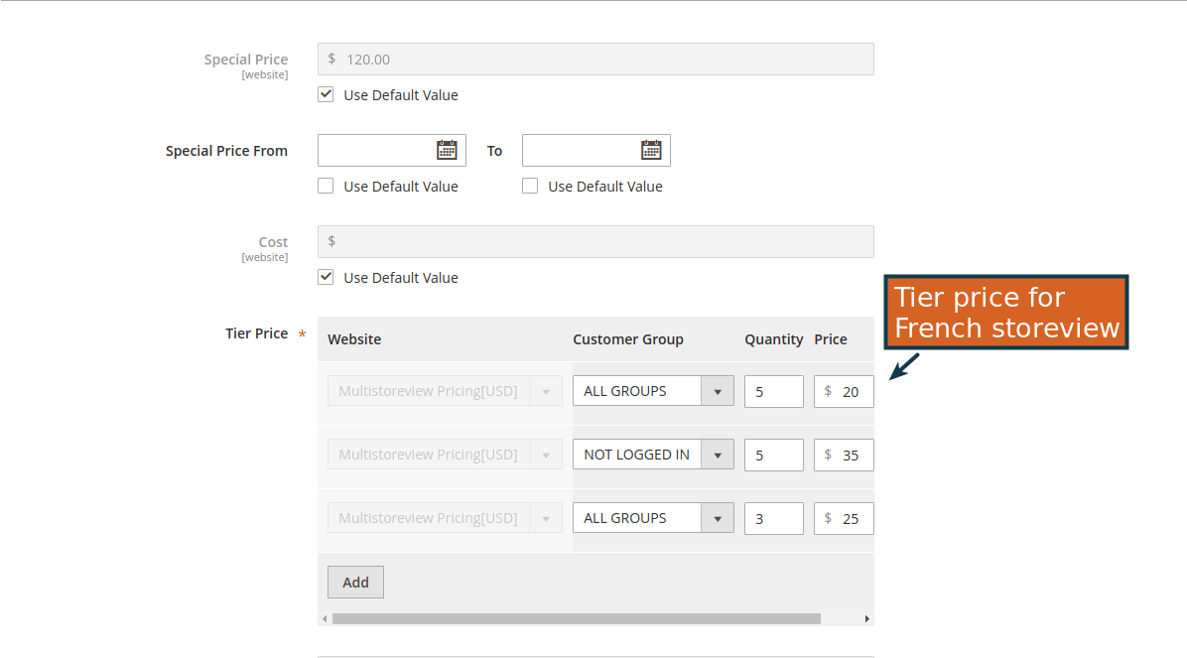

Frontend example
Display price base on your Store view wise.

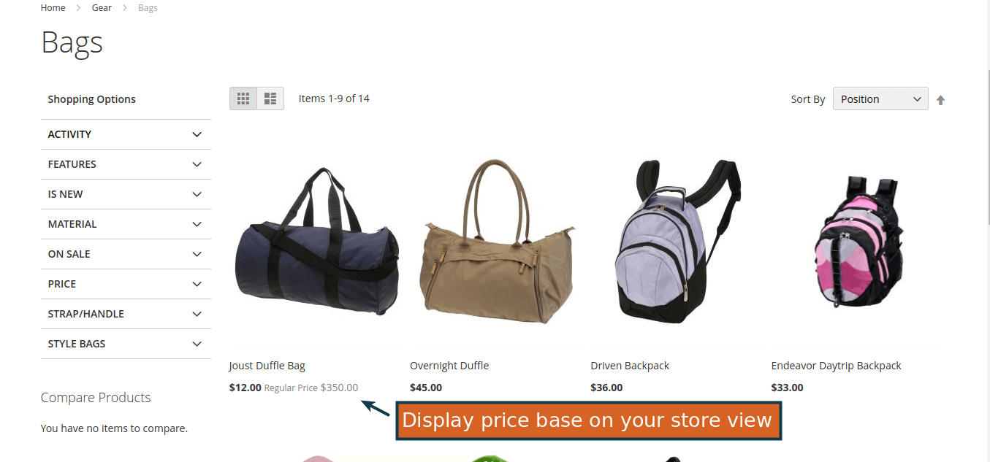

When we change store as a French in frontend then price changed with store and Currency wise.
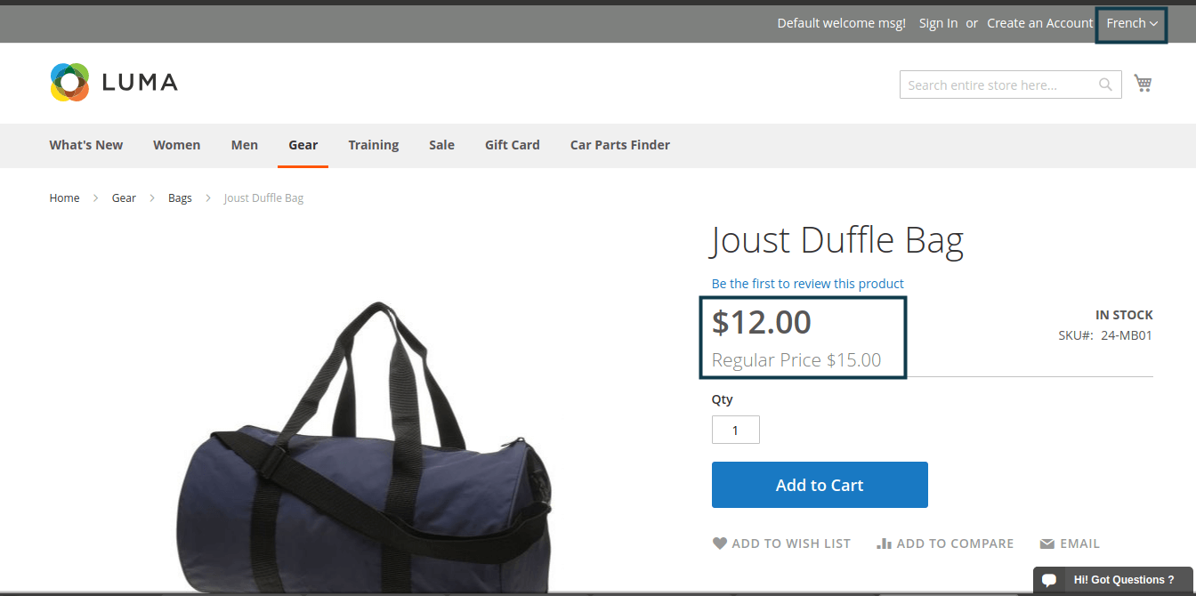

When we change store as a German in frontend then price changed with store and Currency wise.

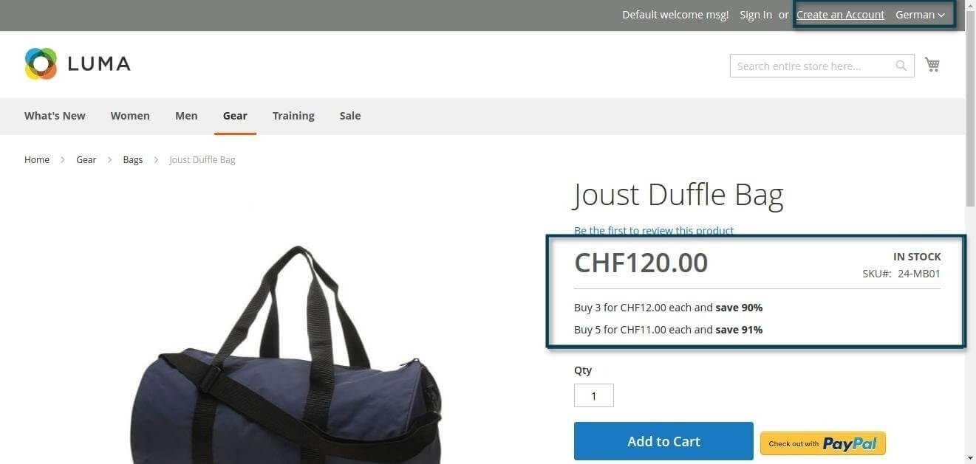

When we change store as a EUR-euro in frontend then price changed with store and Currency wise.

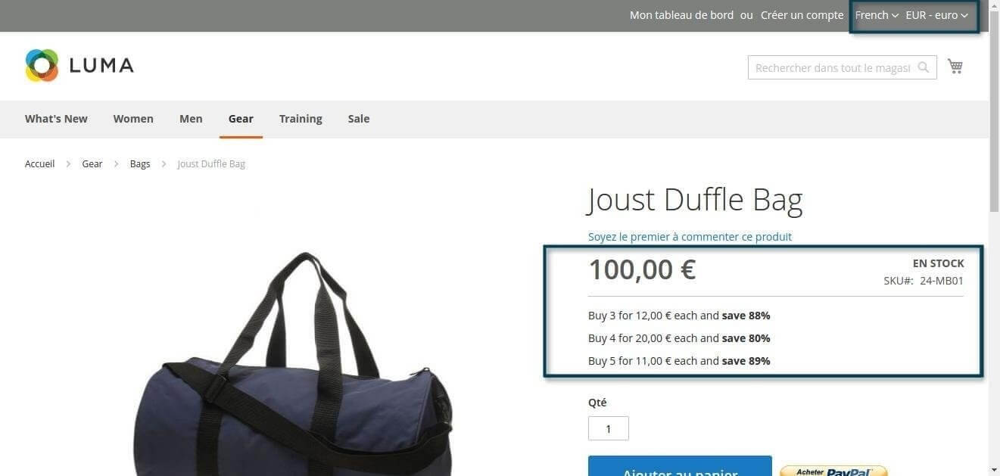

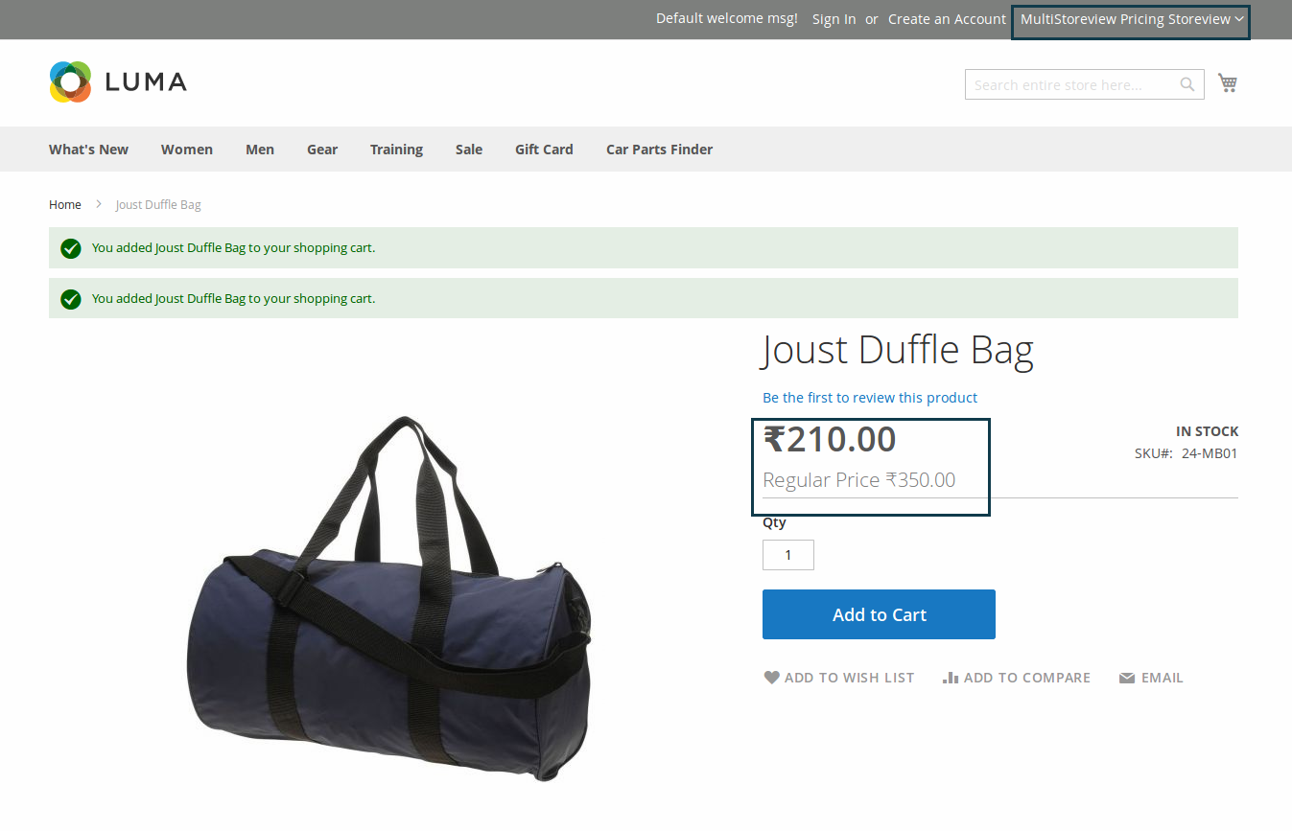
When we change store in frontend then price changed with store
and Currency wise.

When we change store as a English in frontend then price changed
with store and Currency wise.

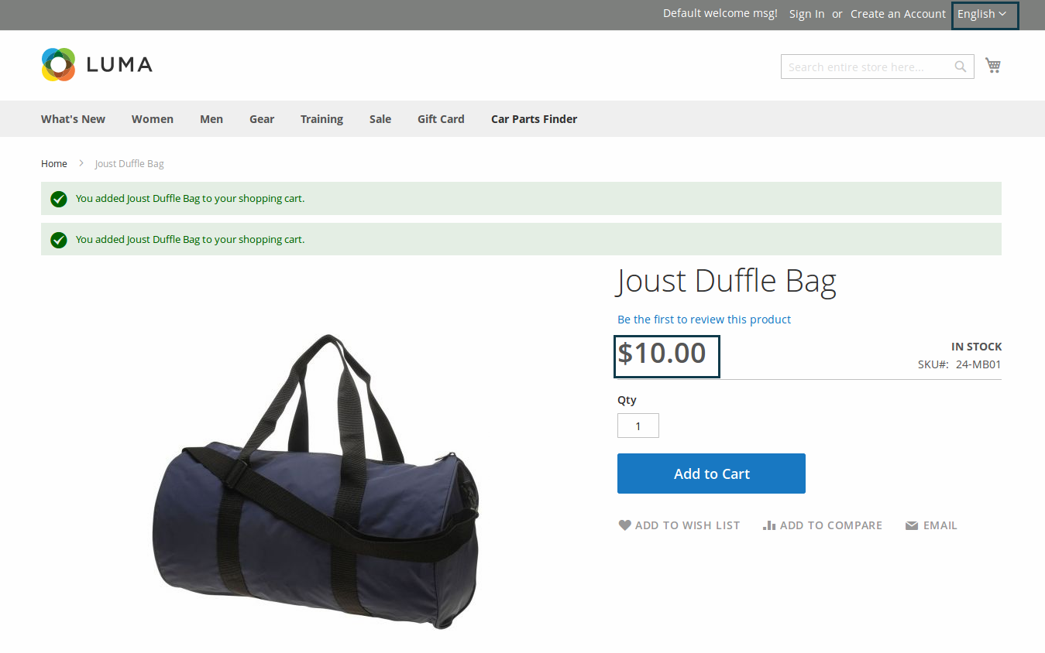

Csv file description

1) id → Serial Number of csv rows
2) sku → Enter your product sku
3) price → Set price for specific product
4) store_id → This field is used to define the Store Id of the product which makes
changes in perticular store
5) special_price → It defines the special price of the product
6) msrp → Set manufacturer's suggested retail price of product
7) cost → It defines the cost price of the product
8) special_from_date → It defines when the special price offer will start
9) special_to_date → It defines when the special price offer will End
10) msrp_display_actual_price_type → Set actual manufacturer's suggested retail price of product
11) tier_price → set tier price for product

Thank you!
If you have any questions or feature suggestions, please contact us at: https://www.mageants.com/contact-us

Your feedback is absolutely welcome!

